Golden Eagle District

2018 Camporee

Event Guide for
Patrol and Unit Leaders

April 20-22, 2018

Firestone Scout Reservation
19001 Tonner Canyon Rd.
Brea, CA 92821

This Camporee will be conducted by
the Kiowa chapter of the Tuku’ut lodge (#033) of the Order of the Arrow
and
the Troops and Crews of the
Golden Eagle District
Greater Los Angeles Area Council

Table of Contents
EVENT INFORMATION 2
DIRECTIONS 2
SUGGESTIONS: 5
For Unit leaders: 5
For Patrol leaders: 5
REQUIRED ITEMS FOR CAMPOREE: 6
REGISTRATION INFORMATION 7
Registration Fee 7
Fast Track Registration 7
Late-Registration 7
GENERAL INFORMATION 8
Patrol Campsites 8
Patches 8
District Trading Post (hours subject to change) 8
ARRIVAL AND DEPARTURE INFORMATION 9
Arrival 9
Check-in 9
Check-Out 9
COMPETITION GUIDELINES for PATROL LEADERS 10
EVENTS 10
Patrol Inspection Event 11
Campsite Inspection Event 11
CODE OF CONDUCT 12
LEADERSHIP 14
MEALS 14
FREE TIME 14
CAMPFIRE AND ORDER OF THE ARROW CALLOUT 14
PATROL LEADERS CHECK IN/OUT FORM 16
UNIT LEADERS CAMPOREE 2018 REGISTRATION FORM 17

EVENT INFORMATION

Overview

WHO: Approximately 300 Boy Scouts, Venturers, and Scouters (adults) from the Golden Eagle District in the Greater Los Angeles Area Council.

WHAT: A district-wide Camporee emphasizing Scout skills and fun.

WHEN: Friday, April 20, 2018 through Sunday, April 22, 2018
Check-in begins at 5 p.m. on Friday. Check-out ends at 11 a.m. on Sunday.

WHERE: Firestone Scout Reservation
19001 Tonner Canyon Rd.
Brea, CA 92821

WHY: To develop Scouting skills, foster brotherhood, and to increase the level of Scouting activities in the San Gabriel Valley.

HOW: This leaders guide contains many details about our Camporee. If you need additional information, please contact:

Ken Hirscht at khirscht@goldeneagledistrict.org

DIRECTIONS

Most units will likely take the 57 Fwy South:

Directions:
- Exit Brea Canyon Rd. and turn right (heading south).
- Proceed to Tonner Canyon Rd. and turn left.
- Just past the freeway underpass is a manned security gate. The guard should let you through.
- Proceed for about 1.0 mile to the Camporee entrance on the right. Look for the signs.

Note: Camporee will be held in a “new” campsite at Firestone. This new campsite is about 2/3 of a mile before the main entrance to Firestone.

Refer to the maps on the following pages.

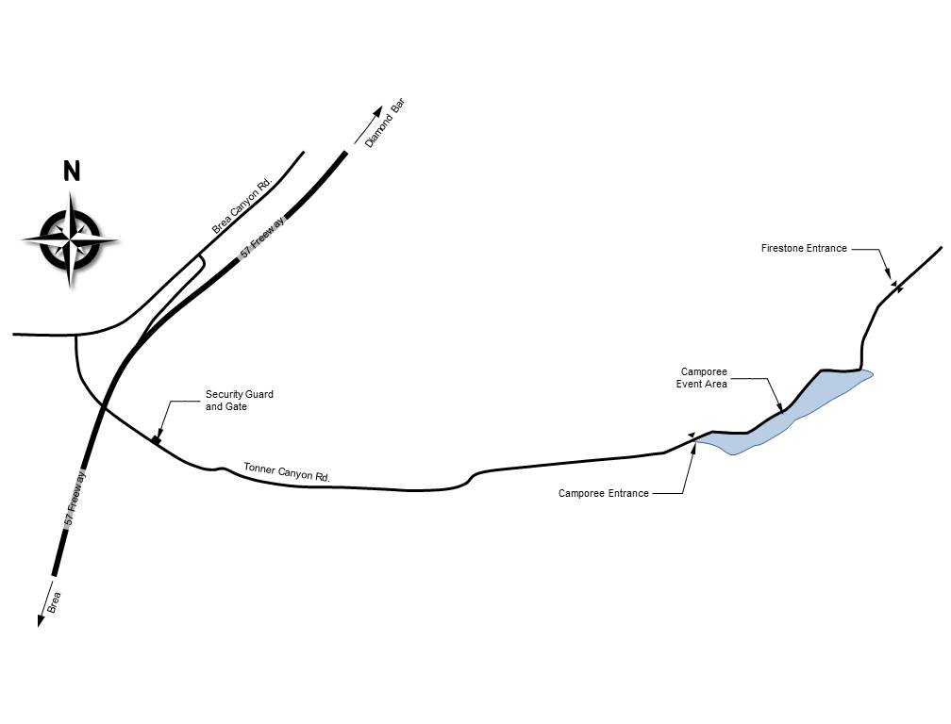
Directions to Firestone

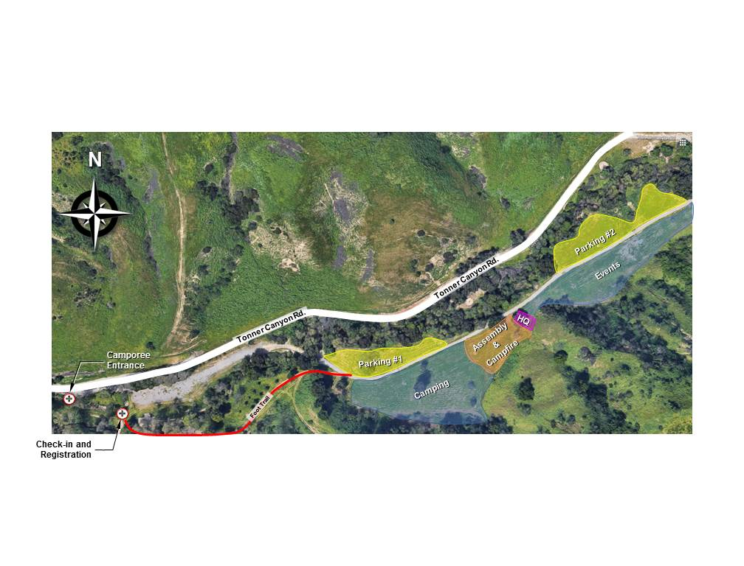
Camporee Area Detail

SUGGESTIONS:

For Unit leaders:
(to support your patrol leaders and Scouts at Camporee)

- Have patrols design and prepare patrol flags. The flags are required for several purposes during the day: Judging of patrol spirit, patrol flag competition and during campfire.
- Secure all required equipment for the troop and patrol.
- Properly label or identify all troop and patrol articles.
- Procure all badges of office, troop numerals, etc. and ensure that they are all properly attached to the Scout and Scouter uniforms.
- Ensure that all tents, dining fly etc., meet the required fire retardant standards.
- Have all patrol information displayed in campsites.
- Have a gateway or camp gadget.

For Patrol leaders:
(to support your patrol at Camporee)

- Design and prepare a patrol flag. The flag is required for several purposes during the day: Judging of patrol spirit, patrol flag competition and during campfire.
- Ensure your patrol equipment is ready for the event.
- Properly label or identify all patrol articles.
- Procure all badges of office, troop numerals, insignia, etc. and ensure that they are all properly attached to the Scout uniforms.
- Ensure that all tents, dining fly, etc. meet the required fire retardant standards.
- Have a gateway OR camp gadget – you are not required to have both.
- Ensure every member of the patrol has a medical form in their pocket throughout the entire event.
- Ensure your patrol members have studied their Scout Handbooks.

REQUIRED ITEMS FOR CAMPOREE:

- Completed Check-in/Check-out form (Patrol Roster) found in this packet.

- A copy of your registration form and your registration receipt to verify registration in case of any problems.

- Two Copies of Annual Health and Medical Form for each Patrol member.
      - 1st copy: To be carried by the Scout during the entire event.
      - 2nd copy: To be handed in by the Patrol Leader at check-in. This will be returned at check-out.

HEALTH FORM DOWNLOAD
http://www.Scouting.org/filestore/HealthSafety/pdf/680-001_AB.pdf

If any Scout does not have a medical/health records form, the unit leader will be asked to obtain one immediately. If one cannot be obtained immediately, then the Scout must return home until the medical/health records form is obtained.

Required forms are contained in this packet and may also be downloaded online at
www.goldeneagledistrict.org

REGISTRATION INFORMATION

Registration Fee

The cost is $18.00 per person, Scout or Adult, through April 12, 2018. All units should be registered by this date and no later. You may register online following the links at www.goldeneagledistrict.org

Day registration for all visitors regardless of unit affiliations will be $6 per person to be paid at Roundtable or upon arrival. Please send a head count and roster of all day visitors to Martin Cardenas, Camporee Registrar at mcardenas@goldeneagledistrict.org no later than Thursday, April 12, 2018. All daytime attendees must be “pre-registered”.

Walk-in visitors will not be allowed prior to 6:30 p.m. and then only for the camp-fire. All visitors must check in and out with the registrar and receive event identification.

Fast Track Registration
You may pre-register at the roundtable on April 12th and be given a pass which will allow you to not have to wait in line for registration. All required materials and payment must be received by that date. All Scouts for the patrol must be ready to be admitted using the fast pass. There can be no exceptions.

Late-Registration
The registration deadline is Friday, April 13, 2018 - seven (7) days before Camporee AT MIDNIGHT.

All registrations after April 13, 2018 are on a space available basis and must be made online. A late fee of $5.00 per person will be applied to these reservations. Online Registration cut-off date is 4/19/18.

For additional information regarding registration, please contact Martin Cardenas at mcardenas@goldeneagledistrict.org

GENERAL INFORMATION

Patrol Campsites
To the extent practicable, patrols from the same troop will be assigned non-adjacent campsites to separate them from one another. Separation ensures that each patrol is judged on its own merit.

Charcoal fires may not be used in the patrol campsite. Food containers should be kept safely above ground.

Each patrol will be assigned a campsite. Prepare for camp sites no larger than 20’ x 30’.

There will be no tables in the campsites nor will there be shade, therefore it is strongly recommended that you bring these items in order to make your weekend a pleasurable one.

There are no trash receptacles either. All units must plan to bag their trash and take it home for proper disposal.

Patches
Participation patches will be issued to the patrol leader after the patrol checkout sheet is signed by a member of the Camporee check-out staff. The unit leader should make arrangements with their patrol leadership to get the patches to participants at a time designated by your unit.

District Trading Post (hours subject to change)
Saturday, April 21, 2018 from 12:00 p.m. until 5:00 p.m.

Come and support our District Round Table by purchasing your snacks and other items at the Camporee Trading Post. This year we will be offering the traditional snacks, sodas, and other items.

ARRIVAL AND DEPARTURE INFORMATION

Arrival
All units transporting patrol and troop gear by trailer will be asked to park in designated parking spaces. Those transporting youth participants should drop them off at check in and direct the youth to hike in following designated signs.

Check-in
Friday, April 20, 2018 from 5:00 p.m. to 8:00 p.m.

For this Camporee, the check-in procedure is similar to Summer Camp. That is, Medical Records Forms and Activity Consent Form are to be handed in at the time the patrol checks in to Camporee.

At the time of check-in, the Patrol Leader is to hand in the following:

- A signed copy of Medical Records Forms for each Patrol member.
- A completed Check-in/Check-out form (patrol roster – page 16 in this guide).

Unit Leaders are asked to provide the following:

- A copy of your registration form (page 17 in this guide)
- Your registration receipt to verify payment if necessary.

Check-Out
All Units should leave before 11:00 a.m., Sunday, April 22, 2018. Please make sure that you have transportation available before that time. As usual, we expect your unit to leave your campsite clean or cleaner than you found it. A Unit representative must be present to pick up patches at the time of checkout.

Early checkout for units needing to leave on Saturday will take place after the campfire. Contact Headquarters for further instructions.

COMPETITION GUIDELINES for PATROL LEADERS

Welcome to your 2018 Golden Eagle District Camporee. Patrol leaders, we want to wish you and your patrol the best of luck. You and your patrol members will be competing with patrols from other troops, as well as the other patrols from your own troop to see who will be the “TOP PATROL” at Camporee.

As a patrol leader, you will want to make sure that all of your patrol members know their basic Scouting skills. Does everyone know how to tie a bowline? Does everyone know the different kinds of fire lays that can be used and how to build them? Now is the time to find out. Help you patrol members in the areas with which they will have trouble. Schedule a pre-Camporee outing to teach, test, and prepare your patrol.

ANY MEMBER OF YOUR PATROL THAT IS AN EAGLE SCOUT WILL NOT BE ALLOWED TO COMPETE. It is recommended that senior patrols, predominantly made up of Eagle Scouts, contact the Camporee chairman to express interest in participation on staff.

The structure of the events will be the same as past Camporees. Each event will contain a skill component as well as an element of sportsmanship. Each troop within the Golden Eagle District is asked to participate in hosting an event. If you would like to be assigned responsibility for a particular event, please have your unit leader contact James Muñoz at jmunoz@goldeneagledistrict.org.

Scoring will be conducted similar to the Olympics. Each patrol will receive points for the ribbons they secure in each event. The Top Camporee patrols will be recognized.

EVENTS
- Uniform Inspection
- Fire Building
- First Aid
- Knots
- Scout Golf (Scout History)
- Flag Etiquette
- Knife & Ax Safety
- Campsite Inspection
- Orienteering
- Lashings
- Physical Fitness

** All events will be timed!

This is a competition. You are being judged on your knowledge and performance in common Scouting knowledge and tasks. No BSA Handbooks or cell phones will be allowed in the event area.

Upon the completion of Camporee, patrols are encouraged to review with a Scoutmaster or other adult leader the patrol’s strengths and opportunities and seek positive growth of knowledge in all areas of Scoutcraft.

Patrol Inspection Event
Inspection includes two major ideals of Scouting: Uniform Wear and Being Prepared (a.k.a. having your essentials).

You are REQUIRED to wear the “FULL OFFICIAL UNIFORM” (Field Uniform: sometimes called a Class A uniform) designated for “SPECIAL OUTDOOR OCCASIONS” as stated in the Boy Scout handbook during the following activities:

- Transportation to and from Camporee
- Check in and out
- Inspection
- Flag ceremony
- Campfire
- Scout’s Own

At all other times Scouts are encouraged to wear the uniform designated in the handbook for “OUTDOOR ACTIVITIES” (Activity Uniform: sometimes called a Class B uniform). Each member of the patrol must carry his “Ten Essentials” at all times.

Campsite Inspection Event
Between breakfast and lunch, each patrol campsite will be inspected for safety and neatness. Patrols are not to be in their campsites during this time. Campsite Inspection criteria will include but is not limited to:
- Patrol Duty Roster, Menu, Neat Map of Patrol campsite and area, Fireguard Chart, Safety Postings (tripping hazards, etc.) and placement
- Cleanliness and Organization. Use of campsite space and removal of trash.
- Gateway OR Camp Gadget of your own design.
- Proper storage for food and Patrol cooking/eating items.
- Visual inspection of each tent interior. Prior to leaving the campsite, open & tie the outer door of tent so that inside is visually accessible from exterior of tent. Patrols not following this instruction will be downgraded on tent inspection.
All members of the patrol must leave their personal mess (eating) kit and personal cleaning kit in their patrol’s central storage. This will prevent any animals from entering tents. Make note on the patrol storage where these items are being stored and can be found so that the inspectors can grade appropriately.

CODE OF CONDUCT

I recognize that my personal conduct and that of all participants attending the Camporee will do much to enhance the image of Scouting. I therefore accept the following Code of Conduct.

- The Scout Oath and Scout Law will be my guide throughout the Camporee.
- I will set a good example by keeping myself neatly dressed and presentable. The official field uniform will be worn when required. During designated events on Saturday an “Activity uniform” may be worn.
- I expect to attend all scheduled activities and take part in as many optional activities as I am able.
- In consideration of the other participants at the Camporee, I agree to be in my tent and remain quiet from lights out to reveille.
- I will be responsible for keeping my tent clean and neat, and will adhere to all Camporee policies and regulations.
- I pledge to do my share to prevent littering and defacing of the Camporee site.
- I agree that no gambling of any kind will be permitted.
- I understand that the illegal possession or use of drugs, alcohol, harmful substances, fireworks and firearms is strictly prohibited.
- I understand that I will be personally responsible for any loss, breakage or theft of property which I cause.
- Campsite etiquette will be strictly enforced. Permission must be granted before entering another Patrol’s campsite and no one is permitted in someone else’s campsites when the campsite is unattended. Unit leaders will be informed of violations.

Remember, the theme for this year’s Camporee is

“NEW CHANGES”

PATROL LEADER CHECK LIST:

- Remind all your patrol members to have their Medical Release Form on them and in a safe place. Make sure members of your patrol have their Ten Essentials.

- Be sure that you and your patrol members read and understand the Code of Conduct and all the safety procedures for your own safety.

- Make sure you and your patrol members understand the agenda for the Camporee and the times for each event.

- Respect other patrols’ campsites and make sure all your patrol items are marked with your patrol name and your name as well.

- All questions that are going to be asked of you and your patrol members will come out of the Boy Scout Handbook.

- Be sure to bring your patrol flag. Take it with you to all events.

- Be sure that your patrol duty roster, menu, fireguard chart, map and other information are fully completed and legible and posted in an area that can be easily located.

- Make sure that all the proper patches are attached to the proper uniform and on the right location on the Scout shirt. Make sure all patrol members are wearing either pants or shorts - deductions will be taken at uniform inspection for patrol members not wearing the same uniform.

- Once you and your patrol members have read the whole packet, you will “Be Prepared” for this year’s Golden Eagle District Camporee.

- Remember size of campsites may be as small as 20’ x 30’.

- Bring three (3) copies of your patrol’s Completed Check In/Out Form (page 16).

- It is suggested that patrol members wear a “troop” or “camp” t-shirt under their “Full Uniform” to the morning Flag Ceremony, so that the shirt may be removed during the Events Competition and Lunch.

LEADERSHIP

Adults, non-patrol member youth leadership, parents and siblings will not be permitted to camp and eat with competing patrols. These groups will be provided an area for their own campsite. This will allow the competing patrols to show the inspectors what they are capable of accomplishing. During competition period of Camporee, only inspectors will be allowed in patrol sites. The competing patrols should have no contact with outside leadership, other than to coordinate gear drops, from check-in to the completion of the competition events on Saturday.

MEALS

Patrol leadership and members will not be permitted to camp and/or eat with other competing patrols. Leaders, parents and siblings will not be permitted to eat with your patrols. Those groups will be provided an area for their own campsite. All attending adults are encouraged to participate as Camporee staff when not conducting the event assigned to your unit. Adults are encouraged to participate in the Scouter food plan and should register for the meals in the online registration. Please contact Ken Hirscht at khirscht@goldeneagledistrict.org for additional information on the food plan.

FREE TIME

Following the completion of events, there will be free time. Activities will be varied. We will also be having a Leadership Roundtable on information such as Youth Protection and other risk management topics. The Camporee Trading Post will also be open.

CAMPFIRE AND ORDER OF THE ARROW CALLOUT

The Campfire ceremony is open to parents, guardians and patrol member’s parents and guardians (don’t forget to tell your patrol members to ask their parents and family members to come to the campfire on Saturday night). It is at this time that awards will be given for the events during the day.

Campfire formation will begin at 7:00 p.m. Saturday evening. Each patrol will be asked to participate with either a skit or song. If a unit would like to perform something special at the campfire, please contact Mike Wiesner at mwiesner@goldeneagledistrict.org.

During the campfire the, Order of the Arrow callout will commence for O/A candidates.

Camporee Agenda

FRIDAY April 20, 2018
Start End Activity
5:00 p.m. 8:00 p.m. Check-In/Inspection Event (Full Uniform)
6:00 p.m. 8:00 p.m. Dinner and Clean Up
8:30 p.m. 9:00 p.m. Patrol Leader Meeting at Headquarters
9:30 p.m. 10:00 p.m. Staff Meeting at Headquarters
10:00 p.m. Lights Out – All quiet

SATURDAY April 21, 2018
Start End Activity
6:30 a.m. Reveille
6:30 a.m. 8:00 a.m. Breakfast & Clean-up
8:30 a.m. 9:00 a.m. Welcome and Flag Ceremony (Full Uniform)
9:00 a.m. 1:00 p.m. Morning Events
1:00 p.m. 1:30 p.m. Trail lunch / campsite inspection
1:30 p.m. 4:30 p.m. Fun Events
4:30 p.m. 5:00 p.m. Open time
5:00 p.m. 7:00 p.m. Dinner & Clean-up
7:00 p.m. 7:30 p.m. Open time
7:30 p.m. 7:45 p.m. Campfire formation (Full Uniform)
7:45 p.m. 9:15 p.m. Campfire ceremony (Full Uniform)
9:15 p.m. 9:45 p.m. Order of the Arrow Callout Ceremony (Full Uniform)
10:00 p.m. Lights Out

SUNDAY April 22, 2018
Start End Activity
6:30 a.m. Reveille
6:30 a.m. 8:00 a.m. Breakfast & Clean-up
8:15 a.m. Contact Headquarters to prepare for Checkout
8:30 a.m. 9:00 a.m. Scout’s Own (Full Uniform)
9:00 a.m. 11:00 a.m. Return Forms - Check Out & Evaluation (Full Uniform)

PATROL LEADERS CHECK IN/OUT FORM

BRING 3 COPIES OF THIS COMPLETED FORM TO CAMPOREE

TIME: __________

Unit |  | Patrol Name |  | # of Scouts

Members registered for Golden Eagle District Camporee
Patrol Leader:
Asst. Patrol Leader
Patrol Member
Patrol Member
Patrol Member
Patrol Member
Patrol Member
Patrol Member
Patrol Member
Patrol Member

All members of my Patrol have read and agree to abide by the Code of Conduct.

Signature of Patrol Leader:

THE FOLLOWING IS TO BE COMPLETED BY A CAMPOREE STAFF MEMBER

ASSIGNED CAMPSITE #
NUM MEDICAL FORMS RECEIVED |  |  |  |  | SIGNATURE OF CHECK-IN STAFF

YOU HAVE NOW COMPLETED CHECK-IN
YOU MAY NOW PROCEED TO INSPECTION

CHECK-OUT
Date: |  |  | Time:

Campsite Clean/Clear
Evaluation Form Completed |  |  |  |  | Signature of Check-Out Staff Person

UNIT LEADERS CAMPOREE 2018 REGISTRATION FORM

Type of Unit: | Troop / Crew / Pack |  |  | Unit #:
 | (circle one)

Name and address of person filing this registration form. | Name and address of person who will be Unit Leader during this Camporee.
Name:  Address:  City:  Phone  (incl. area code) | Name:  Address:  City:  Phone  (incl. area code)

We are registering on or before April 12, 2018  Scouts x $18.00 = $  Adults x $18.00 = $ | All registrations after April 12 must be made directly through  Melissa Bueno, Sr. District Executive.  melissa.bueno@Scouting.org  A $5.00 per person late fee will apply.

COMPETING PATROLS

PATROL NAME/ PATROL LEADER
PATROL NAME/ PATROL LEADER
PATROL NAME/ PATROL LEADER
PATROL NAME/ PATROL LEADER
PATROL NAME/ PATROL LEADER
PATROL NAME/ PATROL LEADER

Please make payments online through www.goldeneagledistrict.org

