2018 Merit Badge University

Event Guide

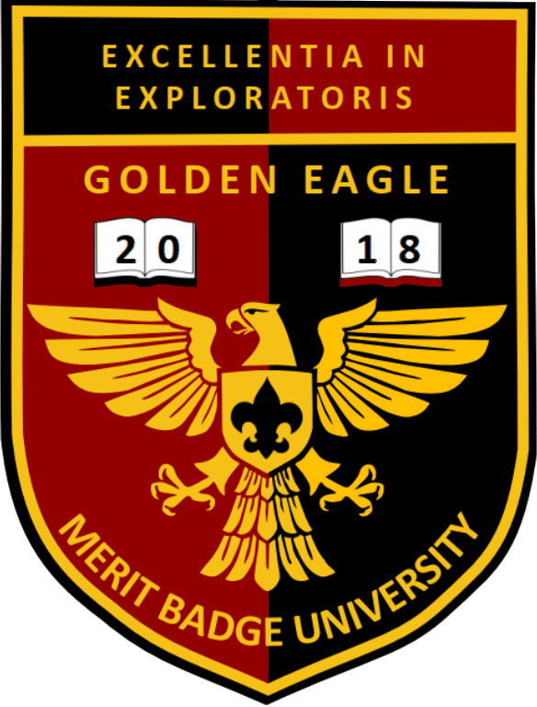

October 27, 2018

Suzanne Middle School
525 Suzanne Road
Walnut, CA 91789

Hosted By:
Golden Eagle District
Greater Los Angeles Area Council

Registration Deadline
October 25, 2018, 11:59 pm

Table of Contents
1 General Description 1
1.1 Merit Badge University (MBU) 1
1.2 Location 1
1.3 Schedule 2
2 Administration 2
2.1 Registration Fee 2
2.2 Maximum Capacity 2
2.3 Merit Badge Class Assignments 2
2.4 How To Register 2
2.5 The MBU Registration Form 3
2.6 How to Submit Registration 3
2.7 Late Registration 3
3 Requirements 3
4 Blue Cards 4
5 Program 4
5.1 Preparation 4
5.2 Pre-requisites or Post-requisites 4
5.3 Partial Completion 5
6 Conduct and Discipline 6
7 Uniforms 6
8 Snacks and Lunch 6
9 Health, Safety, and First Aid 6
10 Lost and Found 6

1 General Description

1.1 Merit Badge University (MBU)
The Merit Badge University (MBU) is an advancement opportunity that is open to any registered Boy Scout, Venturer, or Sea Scout. The event is hosted by the Golden Eagle District of the Greater Los Angeles Area Council (GLAAC).
Questions by parents should first go to Scoutmasters. Scoutmasters having questions should contact or email the event organizer below:
Golden Eagle District Chair
Martin Cardenas
mcardenas@goldeneagledistrict.org
909-261-2840 cell

1.2 Location
The location for MBU will be:
Suzanne Middle School
525 Suzanne Rd
Walnut, CA 91789

The Walnut Valley School District administration has been very generous by providing their facilities, but they are not the host of MBU and the school staff will not be able to answer any questions regarding MBU.
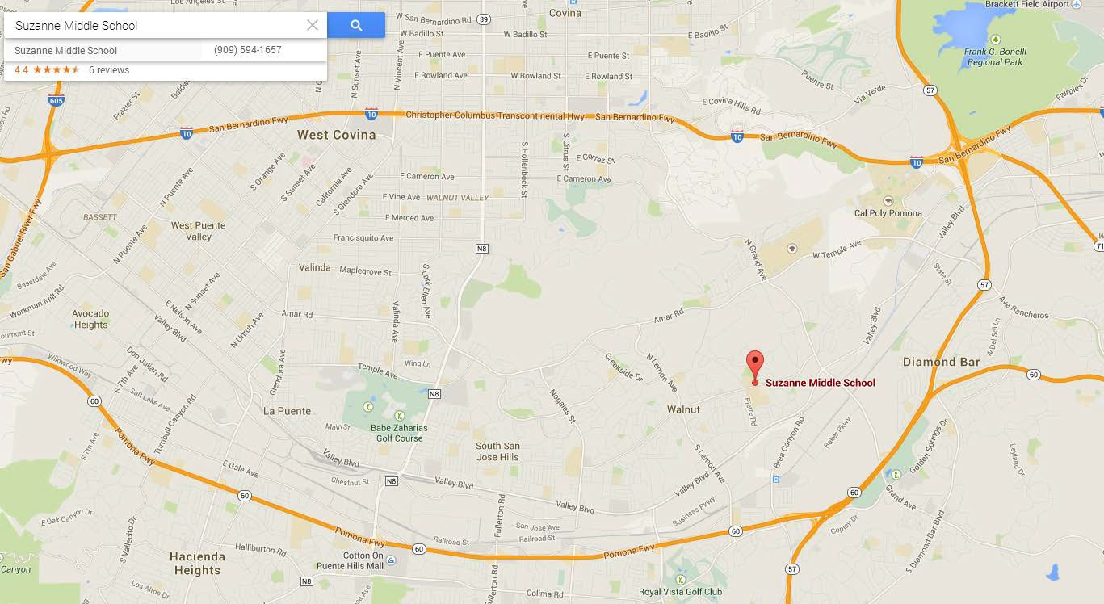
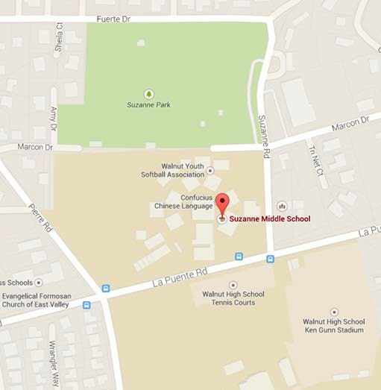
Please do not call Suzanne Middle School!

1.3 Schedule
9:30a | Start of Registration for Morning Session  (those attending an afternoon session will also be checked-in at this time)
10:00 – 11:55a | Morning Session
12:00 noon | Lunch Break
12:30p | Start of Registration for Afternoon session  (for those that did not attend a morning session)
1:00 – 2:55p | Afternoon Session

2 Administration

The most current information for this event regarding class fees, class sizes, pre-requisites, etc. can be found on the district website: www.goldeneagledistrict.org/mbu.html

The fee for attending classes at MBU is $15.00 for each Scout for the whole day, regardless of the number of merit badges being taken. The fee includes an event patch, similar to that shown on the cover page of this guide.
In addition, some merit badges require a Class/Material fee. This fee is to be paid directly to the counselor. Go to to the district website (www.goldeneagledistrict.org/mbu.html) for information on class fees.
An optional lunch will be available for $5.00 (hot dog, chips, drink). Scouts are also welcomed to bring a sack lunch.

2.1 Merit Badge Pamphlets and Worksheets
Scouts are expected to acquire the most recent merit badge pamphlets for their selections, read them, and do the necessary pre-requisites.
The corresponding worksheets are to be used to record all necessary work and pre-requisite work. Web links to the necessary worksheets can be found on the district website.

2.2 How to Register
Go to: www.goldeneagledistrict.org/mbu.html. Read all information pertaining to this event.
The online registration sheet can be found at the bottom of the page. Provide the necessary information and submit the form. The information will be sent to the event organizer. Once they have assigned you to classes, they will inform you by email of your assignments.
Note:
Architecture, Composite Materials, Electricity, Electronics, Fire Safety, and Surveying will require both sessions to complete the one merit badge. Scouts signed up in any of those merit badges will not have the option of a second merit badge.
If online registration presents a hardship, please call the District Chair.
The registration fee will be collected upon check-in. Checks should be made payable to “GLAAC-BSA”. Any associated class/material fees are to be paid directly to the counselor.

The deadline for registration is October 25th, 11:59pm.

2.3 Merit Badge Class Assignments
Scouts are assigned to merit badges in accordance with their preferences submitted on the MBU Registration site. If the Scout’s choice is already filled, they will be contacted in order to resolve the scheduling conflicts.
Class sizes are limited and students are given preference in the order that their registration is received.

2.4 Late Registration
Pending space availability, walk-in registrations may be accepted, but cannot be assured.

3 Requirements
MERIT BADGE PAMPHLETS ARE NOT AVAILABLE AT MBU. Scouts starting and completing any badges at MBU must use the most recent Merit Badge requirements in effect.

4 Blue Cards
Blue Cards (Merit Badge Application, BSA Form #34124), are required. Blue cards must be filled out properly by Scout and signed by the Scoutmaster (or unit leader) when the Scout arrives for MBU.
The Blue Card (Merit Badge Application) is the official record of the Scout’s progress on the merit badge. Scouts are required to submit their completed and signed blue card to the counselor at the beginning of each class.

5 Program

5.1 Preparation
Merely attending Merit Badge University will not satisfy merit badge requirements nor constitute a completed merit badge. Therefore, each Scout should have read his merit badge pamphlet and come prepared to actively participate.
Scouts are required to print the worksheets available at http://www.meritbadge.org/wiki/index.php/Merit_Badge_W orksheets and fill out the answers. Scouts should be ready to take notes and come prepared with a notebook with paper and a pencil.

5.2 Pre-requisites or Post-requisites
Several merit badges will require preparation or follow up work.
It is ideal for a scout to complete the requirements before MBU. They should therefore begin work on those requirements immediately. For those that are able to complete the requirements in advance of MBU, there is a high probability of being able to complete the full requirements the day of MBU.
Merit Badge | Requirements to be completed either before or after MBU
Architecture
(requirements)
Note: This MB will require both sessions.
Aviation  (requirements) | - Requirement #2 (any two, but 2e and 2f are easiest to complete before MBU.)  - Requirement #4(any one)  - Visit an airport (local airports include El Monte Airport, Brackett Airport, Chino Airport). Take a picture of the airport and share at MBU  - Visit FAA facility (needs to be scheduled well in advance)  - Visit an aviation museum or attend an air show (local aviation museums include Chino Airport (Planes of Fame), Santa Monica Airport (Museum of Flying), LAX Airport (Flight Path Learning Center), California Science Center - Los Angeles (Air & Space Museum)
Composite Materials  (requirements)  Note: This MB will require both sessions. | - Minimum age is 14 years old or 9th grade  - Requirement 1a, 1b, 1c  - Requirement 4b  - Requirement 6
Disability Awareness  (requirements) | - Scouts must be prepared to discuss the requirements from the merit badge booklet.  - Requirement #2. Visit an agency that works with people with physical, mental, emotional, or educational disabilities. Collect and read information about the agency’s activities. Learn about opportunities its members have for training, employment, and education. Discuss what you have learned with your counselor.  - Requirement #3 Do TWO of the following: 3a, 3 b, 3c, 3d, 3e  - Requirement #4 - Do EITHER option A or option B:  - Requirement #5. Explain what advocacy is. Do ONE of the following advocacy activities:5a or 5b (8 hours volunteer service) or 5c  - Requirement #6. Refer to Merit badge Pamphlet  - Requirement #7. Refer to Merit badge Pamphlet
Electricity  (requirements)  Note: This MB will require both sessions. | - Requirement #2  - Requirement #7. Tell what you have done to make sure your home circuits are not overloaded.  - Requirement #8  - Requirement #9a
Electronics  (requirements)  Note: This MB will require both sessions. | - Requirement #1  - Requirement #2  - Requirement #6
Fire Safety  (requirements)  Note: This MB will require both sessions. | - Requirement 6  - Requirement 7d  - Requirement 10b and 10c  - Requirement 11  - Requirement 12 (research and prepare to discuss)
Geocaching  (requirements) | - Bring own GPS unit, know how to use it.  - Requirement #5c  - Requirement #7 - Bring a printout from www.geocaching.com showing a listing of the geocaches in your area. At least one of them must show the log entry for your find.  - Requirement #8 a, b, c, d (do one) – bring sufficient proof (printouts, etc)  - Requirement #9: Bring materials and share experience (can be done after MBU)
Law  (requirements) | - Requirement 6. Do ONE of the following:  - a. Attend a session of a civil or criminal court. Write 250 words or more on what you saw.  - b. Plan and conduct a mock trial with your troop or school class. After the trial is over, discuss it with the group.  - Requirement 7. Arrange a visit with a lawyer who works for a business, bank, title company, or government agency. Find out his or her duties and responsibilities. Report what you have learned.
Public Speaking  (requirements) | - Requirement 1: Give a three- to five-minute introduction of yourself to an audience such as your troop, class at school, or some other group.  - Requirement 2: Prepare a three- to five-minute talk on a topic of your choice that incorporates body language and visual aids.  - Requirement 4: Select a topic of interest to your audience. Collect and organize information about this topic and prepare an outline. Write an eight- to 10-minute speech, practice it, then deliver it in the conversational way. (email MB Counselor to available topics of interest)  - Requirement 5: Show you know parliamentary procedure by leading a discussion or meeting according to accepted rules of order; or by answering questions on the rules of order
Surveying  (requirements)  Note: This MB will require both sessions. | - Minimum age is 14 years old or Star Rank  - Previously earned the Have the First Aid MB (bring proof)  - Bring the following:  - Sun protection for the field work portion  - Compass  - Calculator or phone with a calculator. Although not required, a calculator with trigonometric functions and a conversion function from degrees, minutes, seconds to decimal degrees is recommended.

All other requirements not listed above will be covered in each session. However, Scouts are encouraged, as much as possible, to look ahead and to prepare as much as they can.

5.3 Partial Completion
If a Scout is unable to complete his merit badge, the “PARTIAL” completion will be noted on his Merit Badge Application, which will be returned to the Scout. The counselor will retain a copy for their records.
The Scout is responsible for completing his requirements for the merit badge.
The merit badge counselor has the authority to approve or disapprove of prior work done. In the event of a partial completion the scout can continue to work with the counselor after the MBU. The MBU Counselors will be available to certify any work completed after the event. However, the Scout will be responsible for making arrangements with the Counselor. In order to satisfy Youth Protection standards after the event, remember that a Scout is required to be accompanied by a buddy when meeting with the Counselor.

6 Conduct and Discipline
As a participant of the Merit Badge University, everyone promises to:
- Observe the Scout Oath (or Promise) and the Scout Law.
- Wear the official uniform as requested.
- Attend the classes as assigned.
- Be personally responsible for breakage, damage, or loss of property.
- Be courteous to other Scouts, counselors, and staff.
- Clean up each classroom at the end of each session.
- Clean up personal trash after eating.

7 Uniforms
Scouts should wear the official field uniform for MBU. Most units call this a “Class A” uniform. The uniform you normally wear to a troop meeting will be fine.

8 Snacks and Lunch
- All food must be consumed in the designated food area.
- Scouts are expected to clean up after themselves.

9 Health, Safety, and First Aid
- Scouts should take their own medicine if needed during class.
- No running inside or outside the school.
- No roller blades, roller shoes, roller skates, or skateboards are allowed.
- No alcohol, illegal drugs, fireworks, firearms, slingshots, or anything else that might distract from the learning environment. No tobacco or coffee for Scouts.
- The First Aid station is at the Headquarters table.

10 Lost and Found
The MBU Lost and Found is located at the Headquarters table. The return of lost items after the end of MBU is not guaranteed, so be sure to check before you leave. Put your name on EVERYTHING: books, papers, lunch boxes, coats, hats – EVERYTHING.

